Course Title : Big Data Analytics
Course Code : Z1AMC 702
Name: Saumya Patel Registration No: 2511042210022

Experiment 3: Simple Word Count Program in Hadoop

Title: Simple Word Count Program in Hadoop
- Objective
To perform word frequency analysis on a text file using the Hadoop MapReduce WordCount program.
- Procedure
- Create an input text file.
- Upload the file to HDFS.
- Execute the Hadoop WordCount MapReduce job.
- View the generated output.
- Analyze the word frequency results.
- Source Code
- Create input file
echo "Big Data is the future of analytics" > sample.txt
- Create HDFS input directory
hdfs dfs -mkdir /input
- Upload file
hdfs dfs -put sample.txt /input
- Run WordCount
hadoop jar $HADOOP_HOME/share/hadoop/mapreduce/hadoop-mapreduce- examples-*.jar wordcount /input /output
- View results
hdfs dfs -cat /output/part-r-00000
- Screen Shot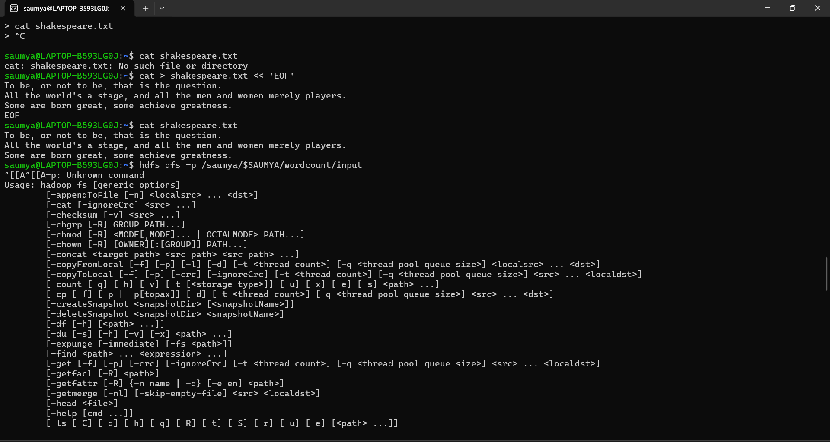

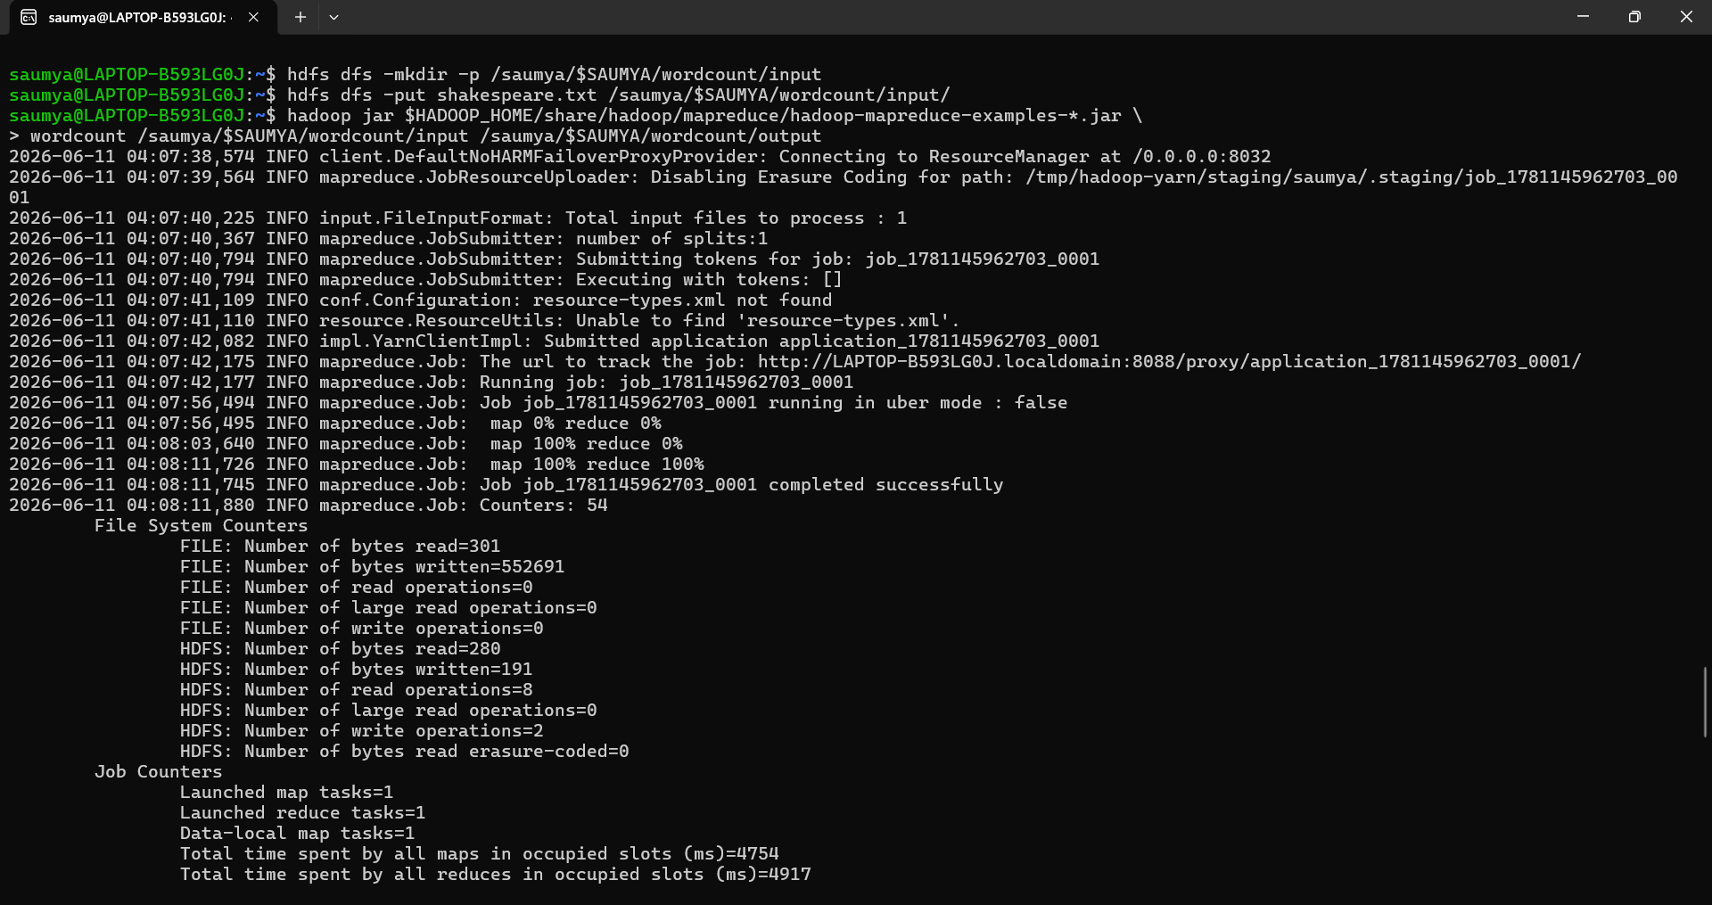
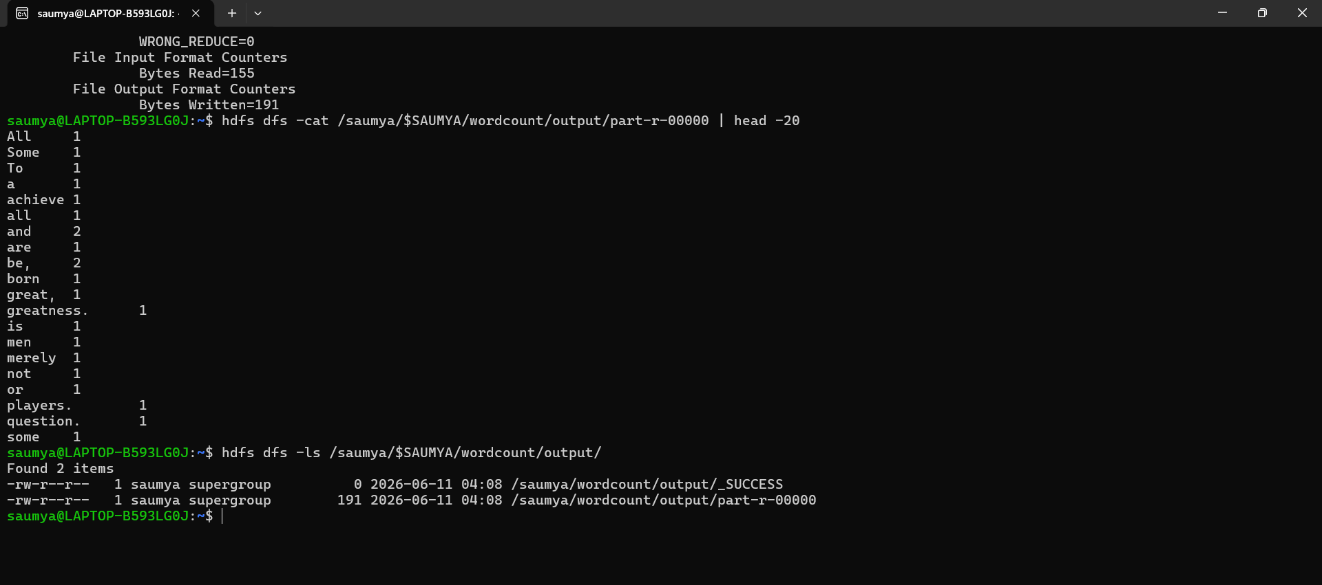
- Conclusion
The Hadoop MapReduce WordCount program was executed successfully. The output displayed the frequency of each word in the input file, demonstrating the distributed processing capability of Hadoop.

